Table of Contents :

Regression Models
1 . Forecasting using Regression Model
2 . Defect count Prediction
3. Cpu load prediction

Text analysis models
4 . Text categorization
5 . Sentiment Analysis

1 . Forecasting using Regression Model :

Problem Statement : Using the below data of 15 months , trying to predict future months data .
Here we need to Predict "Item responses" (dependent variable or Label ) in a month of online application.

Data available :

Year | Month | Item Responses (Forecasted) | Item Responses (Actual)
2016 | Sep | - | 20,374,125
2016 | Oct | - | 42,860,600
2016 | Nov | - | 29,883,382
2016 | Dec | - | 38,317,775
2017 | Jan | - | 41,486,141
2017 | Feb | - | 54,288,800
2017 | Mar | - | 54,864,962
2017 | Apr | - | 28,396,237
2017 | May | - | 34,947,567
2017 | Jun | - | 7,929,473
2017 | Jul | - | 1,335,941
2017 | Aug | - | 7,777,240
2017 | Sep | - | 47,067,175
2017 | Oct | - | 88,765,781
2017 | Nov | - | 74,210,487

Approach Used :

Created regression model in Azure Microsoft ML Studio :

Inputs : Year (Numerical) , Month (Categorical ) , Previous month values (-1 month )
Algorithm : Linear regression
Result :
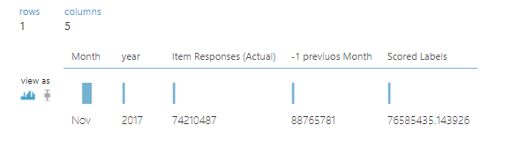
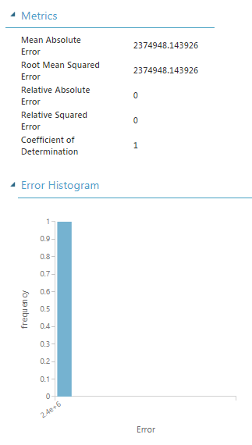

* As we have 15 points , we have used data from Sep- 2016 to Oct - 2017 i.e 14 points for training the model and used one point for test .

Challenges :
1. Is the data enough for training and testing the model .?
2. How to interpret the error histogram .
3. Whether the input "Year" should be normalized ?
4. When we give month as categorized , how will it handle internally ?

2 . Defect count Prediction :

Problem Statement : Every application has new releases or versions , so for better project management , the prediction of defect counts of new release before proceeding to testing help in understanding the estimation of test coverage , required test engineers etc .

Approach :

1 .Collected the influencing factors of defect .

Release | Total number of Test Cases executed | Test Team size | Dev team size | Test case execution Effort | Allocated Development effort | Number of defects
R1 | 43 | 5 | 2.8 | 43 | 490 | 9
R2 | 260 | 10 | 6.5 | 260 | 611 | 42
R3 | 188 | 10 | 6.5 | 282 | 404 | 51
R4 | 271 | 10 | 4.3 | 290 | 604 | 42
R5 | 43 | 9 | 3 | 160 | 145 | 1
R6 | 134 | 11 | 6.8 | 134 | 615 | 40
R7 | 176 | 6 | 4.2 | 110 | 1120
R8 | 388 | 9 | 5.8 | 388 | 1085
...
....

* Apart from release all the variables are used as feature variables .
* "Number of defects" as label or target column
* Based on these parameters we are trying to predict the "Number of defects " by applying Neural network algorithm.

Challenges : 1 . How to find out whether the feature inputs are really influencing the dependent or label variable ?

3. Cpu load prediction :

Problem Statement : When a application hit by browser requests , the CPU usage will be affected . To find the variation of CPU usage(y-axis) based on "calls per minute" (x axis ) .
Approach : Used calls per min as input and predicting the Cpu usage .

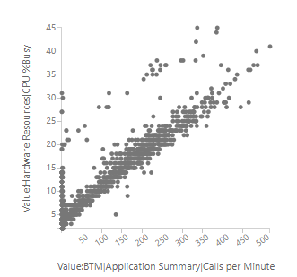

Challenges : how to handle the points above the diagonal line ?

4 . Text categorization :

Objective : Collecting the mobile app reviews or feedbacks and finding the insights into the reviews by categorizing them into different topics like Functional , Performance , security , Reliable etc .

Example :

Text or app reviews | Category
already face earlier incur sms charge | Functional
change phone sim slot | Functional
not design app not look secur | Security
worst app secur base sim | Security
tri login not login shoe difficult tri time everi time problem | Reliability
unabl login | Reliability
login problem | Reliability
....  ..... etc | ....  .... etc

Approach used :

1. Collecting the App reviews .
2. Split the review into sentences as in a review the user may speak about different topics .
- Remove stop words like is , was etc
- Create training data : Manually assign the topics to each splitted review.
Prepared 3800 rows of data .
- Modified the text as below using Rscript :

replace_special_chars , remove_duplicate_chars , replace_numbers ,
convert_to_lower_case , remove_given_stopWords ,stem_words .

- Create vocabulary or dictionary of words from the reviews (using R script ):
(With condition of minimum word occurrence of 3 times)

- Map these vocabulary words with reviews and topics

8 . Used this mapped data to train the model .

Algorithm used : Multiclass neural network

Output :

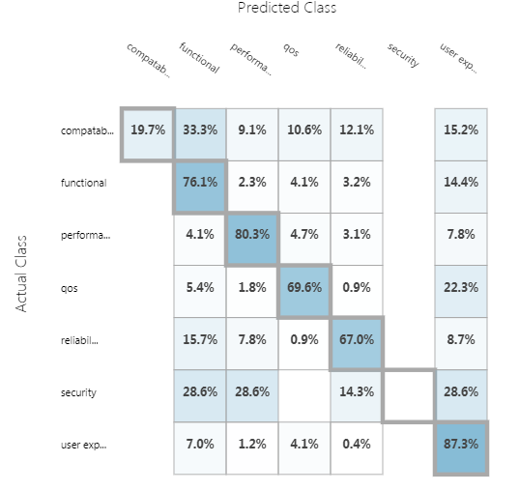

Challenges :
1. What are ways to improve the accuracy ?
2. How to handle the the situation when the same words occur in multiple categories

5 . Sentiment Analysis :

- In the app review we can find the user sentiment by looking at score or rating provided .
- But most of the times it wont tell exact sentiment of users . For ex : some user may give rating as 2 (out of 5) and praise the app functions .
- So in those scenarios instead of just going by rating , we need to be Analyzing the reviews and finding the user sentiment inside the review like Positive , Negative , Neutral .

Approach used :
Same as Text categorization approach , topics we have assigned the as Positive , Negative and Neutral .

Challenges :
1 . Is this approach is right for sentiment analysis ?
2 . We have found some R packages for sentiment analysis like sentimentR , Rsentiment etc . Could you suggest the better package for sentiment analysis.

--------------------------END ----------------------------------------------

